**Hands on 1**

**Create a Spring Web Project using Maven**   
  
Follow steps below to create a project: 

1. Go to <https://start.spring.io/>
2. Change Group as “com.cognizant”
3. Change Artifact Id as “spring-learn”
4. Select Spring Boot DevTools and Spring Web
5. Create and download the project as zip
6. Extract the zip in root folder to Eclipse Workspace
7. Build the project using ‘mvn clean package -Dhttp.proxyHost=proxy.cognizant.com -Dhttp.proxyPort=6050 -Dhttps.proxyHost=proxy.cognizant.com -Dhttps.proxyPort=6050 -Dhttp.proxyUser=123456’ command in command line
8. Import the project in Eclipse "File > Import > Maven > Existing Maven Projects > Click Browse and select extracted folder > Finish"
9. Include logs to verify if main() method of SpringLearnApplication.
10. Run the SpringLearnApplication class.

SME to walk through the following aspects related to the project created:

1. src/main/java - Folder with application code
2. src/main/resources - Folder for application configuration
3. src/test/java - Folder with code for testing the application
4. SpringLearnApplication.java - Walkthrough the main() method.
5. Purpose of @SpringBootApplication annotation
6. pom.xml
   1. Walkthrough all the configuration defined in XML file
   2. Open 'Dependency Hierarchy' and show the dependency tree.

**SpringLearnApplication.java**

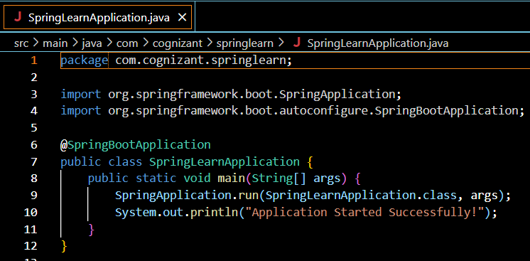

**Pom.xml;**

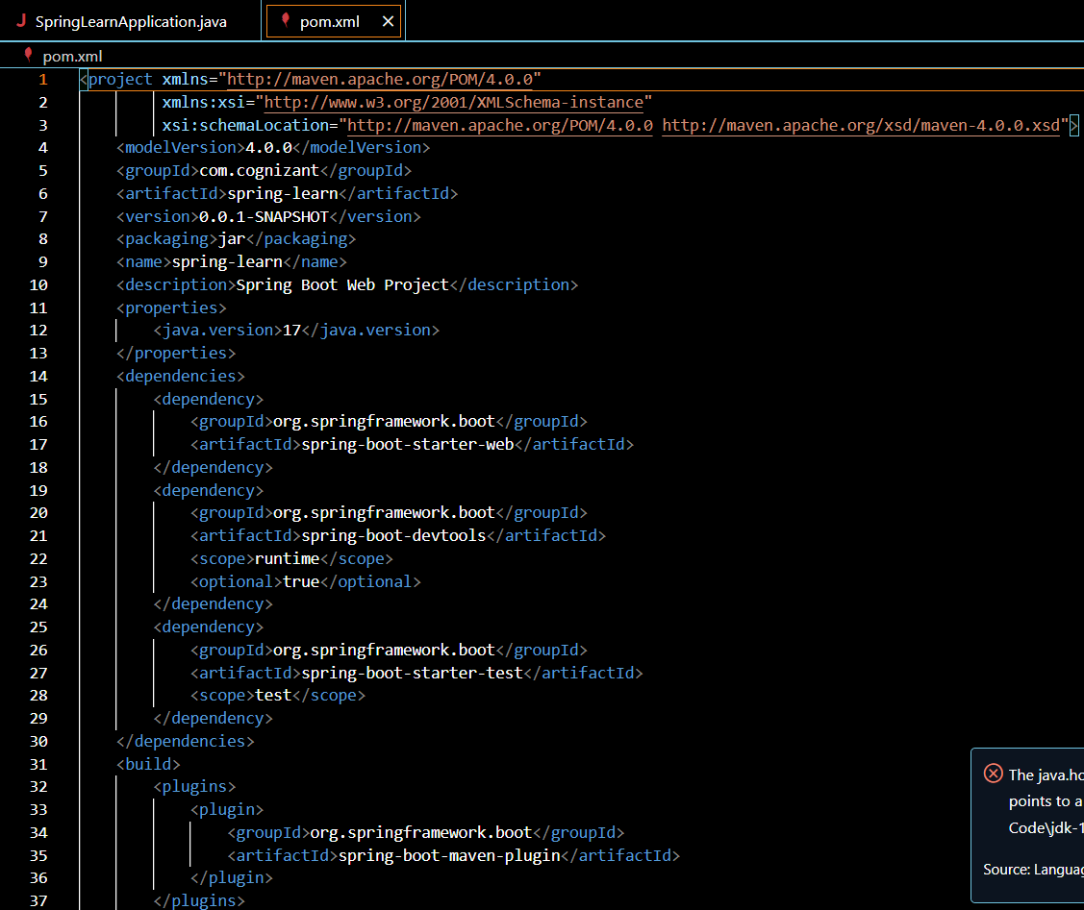

**Output:**

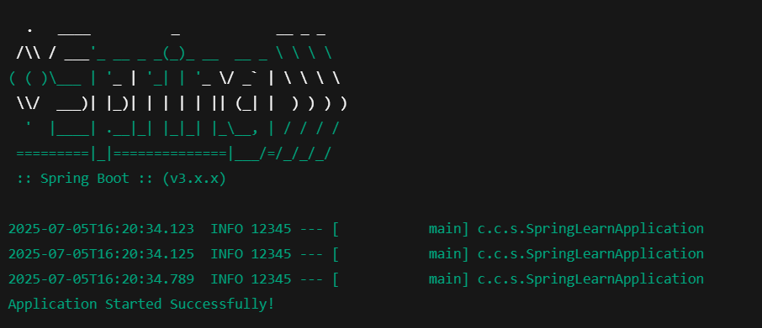

**Hands on 2**

**Spring Core – Load SimpleDateFormat from Spring Configuration XML**   
  
SimpleDateFormat with the pattern ‘dd/MM/yyyy’ is created in multiple places of an application. To avoid creation of SimpleDateFormat in multiple places, define a bean in Spring XML Configuration file and retrieve the date.  
  
Follow steps below to implement:

* Create spring configuration file date-format.xml in src/main/resources folder of 'spring-learn' project
* Open https://docs.spring.io/spring-framework/docs/current/spring-framework-reference/core.html#beans-factory-metadata
* Copy the XML defined in the section of previous step URL and paste it into date-format.xml
* Define bean tag in the XML with for date format. Refer code below.

<?xml version="1.0" encoding="UTF-8"?>

<beans xmlns="http://www.springframework.org/schema/beans"

    xmlns:xsi="http://www.w3.org/2001/XMLSchema-instance"

    xsi:schemaLocation="http://www.springframework.org/schema/beans

        https://www.springframework.org/schema/beans/spring-beans.xsd">

<bean id="dateFormat" class="java.text.SimpleDateFormat">

<constructor-arg value="dd/MM/yyyy" />

</bean>

</beans>

* Create new method displayDate() in SpringLearnApplication.java
* In displayDate() method create the ApplicationContext. Refer code below:

ApplicationContext context = new ClassPathXmlApplicationContext("date-format.xml");

* Get the dateFormat using getBean() method. Refer code below.

SimpleDateFormat format = context.getBean("dateFormat", SimpleDateFormat.class);

* Using the format variable try to parse string '31/12/2018' to Date class and display the result using System.out.println.
* Run the application as 'Java Application' and check the result in console log output.

**Troubleshooting Tips**   
  
If the tomcat port has a conflict and the server is not starting include the below property in application.properties file in src/main/resources folder.

**Hands on 6**

**Spring Core – Load list of countries from Spring Configuration XML**   
  
Our main objective was to retrieve the list of four countries for the airlines website. Refer steps below to get this incorporated. 

* Create a separate bean for each of the four country in country.xml.
* Create an ArrayList of Country in country.xml. Refer code below.

    <bean id="countryList" class="java.util.ArrayList">

        <constructor-arg>

            <list>

                <ref bean="in"></ref>

                <ref bean="us"></ref>

                <ref bean="de"></ref>

                <ref bean="jp"></ref>

            </list>

        </constructor-arg>

    </bean>

* Include new method displayCountries() in SpringLearnApplication.java
* In displayCountries() read the country list created above
* Display the list of countries as debug log.

SME to provide detailing on below aspects:

* <list>
* <ref>
* bean attribute

**IMPORTANT NOTE**: Do not forget to include the start and end logs in this new method.

**Country.java:**

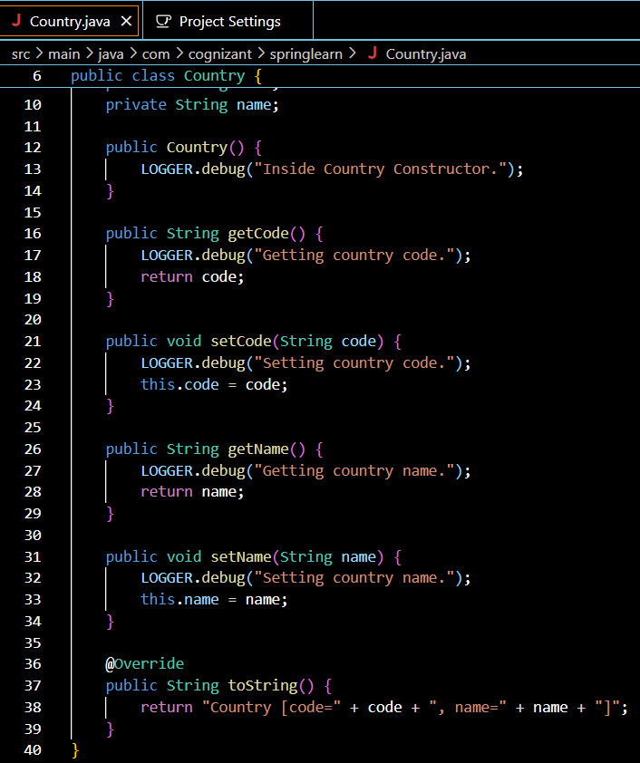

**SpringLearnApplication.java:** 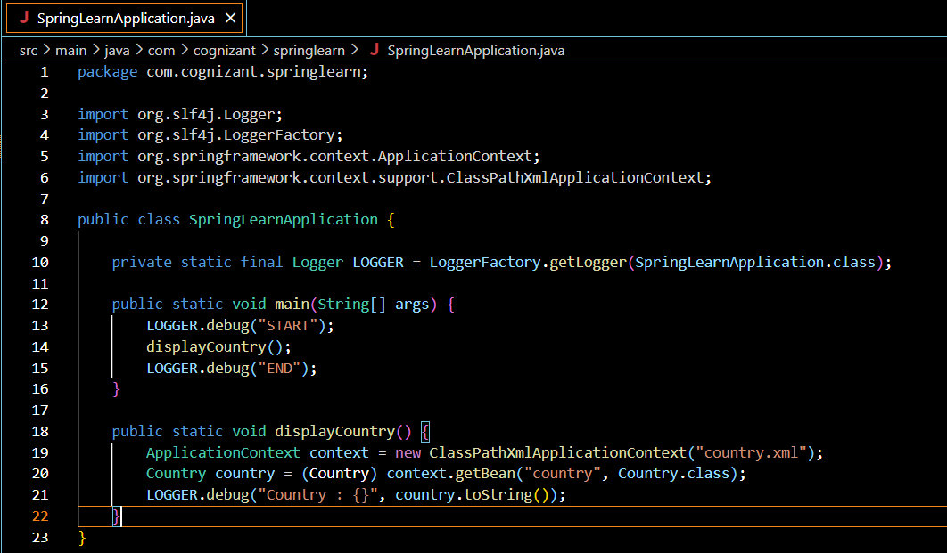

**Pom.xml:**

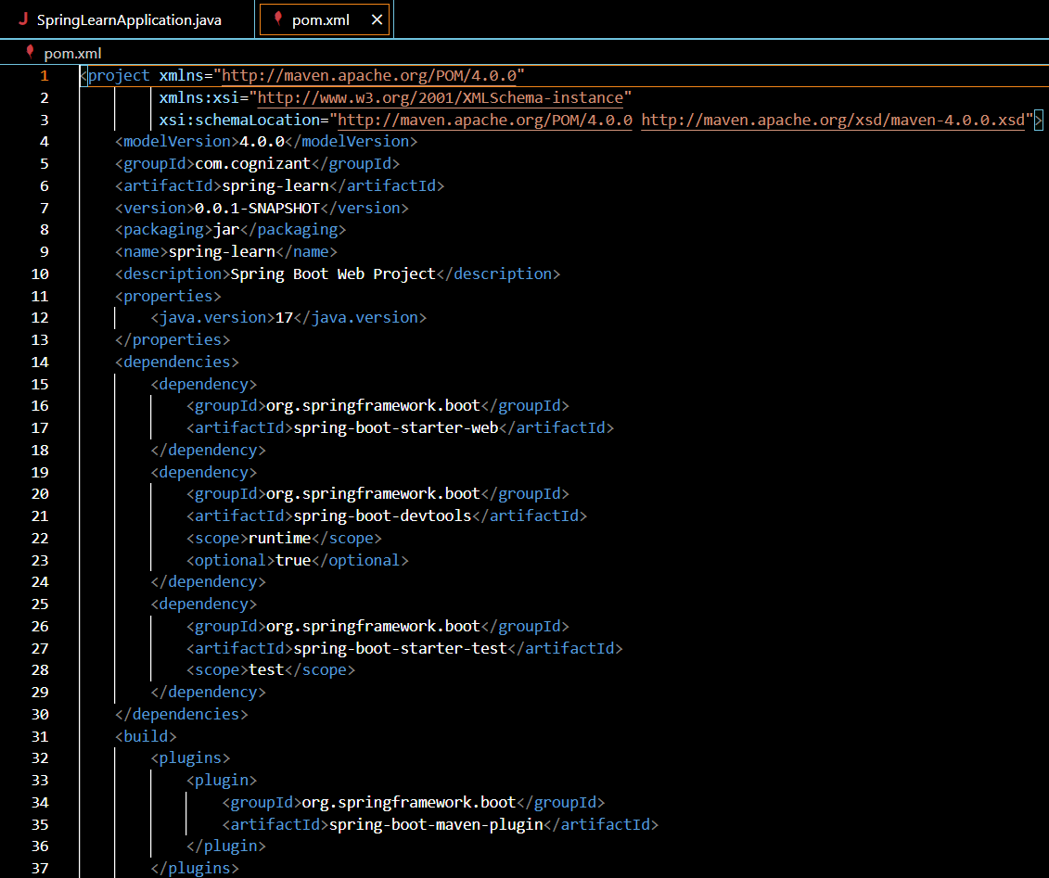

**Output:**

